**UZIMA BOREHOLE DRILLING SYSTEM**

**A project report on the need to computerize the data processing activities of the Uzima Borehole Drilling System**

**Prepared By:**

**Enter your name**

**INDEX NUMBER:**

**SCHOOL:**

**PERIOD:**

**SUBMITTED TO:**

**The Kenya National Examination Council (KNEC)**

***A dissertation submitted in fulfillment of the requirement for the KCSE examination in computer studies*.**

**DATE:**

# DECLARATION

I hereby declare that this project submitted to the Kenya National Examination Council is my work done through the guidelines of my computer teacher only and has not been submitted by anybody else to the Kenya National Examination Council.

**Student Name …………………………...…Supervisor Name………………................**

**Sign……………………………………........ Sign……………………………….….........**

**Date………………………………………… Date…………………………………..........**

# PREFACE

Uzima Borehole Drilling System is a project that has been made with the aim of helping the residents to get water. It has been developed using the Microsoft access database school system to enable the school to bring together its financial resources. This computerized system is also responsible for easing the manipulation of data and ensure fast and efficient access and retrieval of data in the school.

# ACKNOWLEGEMENT

I give special thanks to the Almighty GOD for the far He has taken me and to my parents who found it wise to bring me to school. I extend my sincere gratitude to the school administration for providing a suitable environment for learning computer studies and the required facilities for this project. I also thank my computer teacher. Mr. Enter your teachers name who has empowered me academically and all who have aided me to make the writing of this project successful.

# DEDICATION

This project is a dedication to Declare your family their support all the time. I also give my sincere gratitude to my aunt (enter name)? for the encouragement and support and to all my friends who contributed in making this project successful.

.

Contents

DECLARATION ii

PREFACE iii

ACKNOWLEGEMENT iv

DEDICATION v

LIST OF FIGURES viii

LIST OF TABLES ix

CHAPTER ONE 1

1.1 INTRODUCTION 1

CHAPTER TWO 2

PROBLEM RECOGNTION AND DEFINITION 2

2.1 PROBLEM DEFINITION 2

2.1.1 Advantages of the current system 2

2.1.2 Disadvantages of the current system. 2

2.2 PROPOSED SYSTEM 3

2.2.1 Objectives of the proposed system 3

2.3 SCOPE OF THE SYSTEM 3

2.3.1 Benefits of the proposed system 3

2.3.2Disadvantages of the proposed system 3

2.4 EXISTING STUCTURE 4

2.5 PROJECT SCHEDULE 5

2.6 FEASIBILITY STUDY 6

2.5.1Computer hardware requirements 6

2.5.2Software requirements 6

2.7 INFORMATION GATHERING 7

2.7.1Fact finding 7

CHAPTER THREE 9

SYSTEM DESIGN 9

3.1 FLOWCHAT DESIGN 9

3.2 REQUIREMENT SPECIFICATION 10

3.3 INPUT AND OUTPUT DESIGN 19

3.3.1Input design 19

Figure 15 25

3.3.2File and data storage time 26

3.3.3 Entity-relationship diagram 26

3.3.4 Interpretation 26

CHAPTER FOUR 28

SYSTEM CONTRUCTION 28

4.1 SETTING UP INTEGRITY CONSTRAINTS 28

4.2DATA ENTRY CONSTRAINTS 30

Figure214.2.1Constructing data entry and user interface forms 33

4.2.1Constructing data entry and user interface forms 34

4.3 STARTUP OPTIONS AND LOADER 44

4.3.1Loader 44

4.3.2 Testing and implementing the system 46

4.3.3 Recommendation and conclusion 46

CHAPTER FIVE 47

USER MANUAL 47

5.1 INTRODUCTION 47

5.2 LOADING THE GOLDEN WALL SCHOOL INVENTORY SYSTEM 47

5.3 MODIFYING A FORM 47

RECOMMENDATION 48

CHALLENGES 49

CONCLUSION 50

APPENDIX 51

FLOWCHART SYMBOLS AND THEIR MEANING 51

BIBLIOGRAPHY/REFERENCES 52

# LIST OF FIGURES

Figure 1 …………………………………………………………………………………....12

Figure 2 ………………………………………………………………………………….....17

Figure 3 …………………………………………………………………………………….19

Figure 4 …………………………………………………………………………………….19

Figure 5 …………………………………………………………………………………….20

Figure 6 …………………………………………………………………………………….20

Figure 7……………………………………………………………………………………..21

Figure 8……………………………………………………………………………………..21

Figure 9……………………………………………………………………………………..22

Figure 10…………………………………………………………………………………....22

Figure 11…………………………………………………………………………………….23

Figure 12…………………………………………………………………………………….23

Figure 13…………………………………………………………………………………….24

Figure 14…………………………………………………………………………………….24

Figure 15…………………………………………………………………………………….25

Figure 16…………………………………………………………………….........................26

Figure 17…………………………………………………………………………………….28

Figure 18…………………………………………………………………………………….29

Figure19……………………………………………………………………………………..30

Figure 20…………………………………………………………………….........................31

Figure 21………………………………………………………………………………….....32

Figure 22…………………………………………………………………………………….33

Figure 23…………………………………………………………………………………….33

Figure 24 ……………………………………………………………………………………34

Figure 25…………………………………………………………………………………….35

Figure 26 ……………………………………………………………………………………36

Figure 27……………………………………………………………………………………36

Figure 28 ……………………………………………………………………………………37

Figure 29 ……………………………………………………………………………………37

Figure 30 ……………………………………………………………………………………38

Figure 31 ……………………………………………………………………………………38

Figure 32 ……………………………………………………………………………………39

Figure 33 ……………………………………………………………………………………39

Figure 34 ……………………………………………………………………………………40

Figure 35 ……………………………………………………………………………………41

Figure 36 ……………………………………………………………………………………42

Figure 37 ……………………………………………………………………………………43

# LIST OF TABLES

Table 1…………………………………………………………………………………......5

Table 2……………………………………………………………………………………..6

Table 3….............................................................................................................................10

Table 4…………………………………………………………………………………….10

Table 5…………………………………………………………………………………….10

Table 6 ………………………………………………………………………....................11

Table 7…………………………………………………………………………………….11

Table 8…………………………………………………………………………………….11

Table 9…………………………………………………………………………………….12

Table 10…………………………………………………………………………………...12

Table 11…………………………………………………………………………………...12

Table 12…………………………………………………………………………………...13

Table 13…………………………………………………………………………………...13

Table 14…………………………………………………………………………………...13

Table 15…………………………………………………………………………………...27

Table 16…………………………………………………………………………………...27

# CHAPTER ONE

# INTRODUCTION

Uzima Company is one of the leading borehole service providers in Kenya. They provide borehole drilling services to industrial, commercial and domestic clients. The company offers either symmetric drilling, or core drilling, or geo-technical drilling. After the drilling, they install a water pump. Water pumps are of various types such as submersible electric pumps, solar pumps and hand pumps. The pumps are charged according to; the depth of the borehole, height of the tank above the ground and the type of the pump. They also install tanks and charge depending on the capacity of the tank in liters. The company also offers other services such as plumbing and pump maintenance. The plumping services are charged according to the type of pipes, diameter of the pipes in inches, length of the pipes and the number of outlets. Clients who are interested in these services are required to apply. The company then records their details which include: Name, address, telephone number and details of the intended borehole location among other details. Each client is required to pay survey fees and local authority fees as shown in Table 1. Table 1: Survey and local authority fees Client category Survey fees Local Authority fees Industrial 20,000 50,000 Commercial 15,000 30,000 Domestic 7,000 10,000 Other services are charged based on the rates in Table 2, Table 3 and Table 4. Table 2: Drilling Services Type of drilling Down payment fee Symmetric drilling 130,000 Core drilling 225,000 Geo-Technical drilling 335,000 Table 3: Pump Installation Type of pump Cost Submersible electric pump 90,000 Solar pump 65,000 Hand pump 30,000 2 924116 Table 4: Depth and Height in Meters Depth and Height Cost per Meter 1 - 100 1,000 101 - 200 1,500 201 - 300 2,000 Over 300 2,500

# CHAPTER TWO

# PROBLEM RECOGNTION AND DEFINITION

## 2.1 PROBLEM DEFINITION

After the investigations I carried out in Uzima Borehole Drilling System, I found out that they were using a manual system in keeping and restoring all important records. In the existing system school records are stored in files and during data retrieval there is time wastage since it is difficult to locate the position of a specific file. The current system being used in Uzima Borehole Drilling System is facing many problems like:

* A lot of paper use since a manual system is under use
* There is a lot of boredom for the members due to repetition of the same type of work. At times a manual system is difficult to modify
* At time there is no accuracy

### 2.1.1 Advantages of the current system

* It does not require knowledgeable skills.
* It is a source of job opportunity to many.

### 2.1.2 Disadvantages of the current system.

Type the disadvantages

## 2.2 PROPOSED SYSTEM

The proposed system is going to support the operations of the Uzima Borehole Drilling System in ensuring quality services are provided to the members in the economy.

### 2.2.1 Objectives of the proposed system

## 1. Maintain details of the club members and their roles;

## 2. Maintain details of sports in the club.

## 3. Maintain records of items in the store

## 4. Maintain records of items purchased and their subsequent stock levels

## 5. Maintain records of all facilitation fees for all sports events

## 2.3 SCOPE OF THE SYSTEM

The proposed computerized system will help Uzima Borehole Drilling System:

* Compute payments for the services to farmers
* Compute payments made to farmers for honey deliveries.
* Total sales to members.
* Transport earnings
* Income from training
* Total income for the company

### 2.3.1 Benefits of the proposed system

* It prompts accuracy.
* Proper analysis of the Uzima Borehole Drilling System in terms of development.
* Minimal use of paper work.
* Easy production of analysis results about the members.

### 2.3.2Disadvantages of the proposed system

* + Job replacement of members.

## 2.4 EXISTING STUCTURE

Pay Survey and L/A fees

Order Drilling Service

Pump installation

Tank fittings

Overall Plumbing

Registration

Actual Drilling

**Figure 1**

## 2.5 PROJECT SCHEDULE

Time schedule was illustrated as below

|  |  |  |  |
| --- | --- | --- | --- |
| ACTIVITY | DESCRITION | START | END |
| Research | Scrutinized analysis of the current system and its weakness | Enter date done |  |
| System Analysis | Formulation design of the proposed system |  |  |
| System Design | Coming up with the prototype design of the system |  |  |
| System Coding | Coming up with an input of the program code |  |  |
| System Testing and Debugging | Inputting test data into the new system to identify the bugs and making necessary changes |  |  |
| System Implementation | Putting the new system in use |  |  |
| System Documentation | Coming up with the documentation for the system |  |  |

**Table 1**

## 2.6 FEASIBILITY STUDY

* **SCHEDULE FEASIBILITY**

The development of the computerized proposed system is to be functional after the 7 allocated months.

* **TECHNICAL FEASIBILITY**

The current technology is suitable for the running of this proposed system. It enables the users to run this system with minimal challenges and easily since many people these days are literate.

### 2.5.1Computer hardware requirements

|  |  |
| --- | --- |
| Microprocessor | Pentium 4 and above |
| Keyboard | Standard Keyboard |
| Monitor | TFT monitors |
| Storage Device | Flash Disk or a CD ROM |
| Ms Access version | Ms access 2007 or later |

**Table 2**

### 2.5.2Software requirements

Antivirus program i.e. Kaspersky

Database School software i.e. MS Access

* **OPERATIONAL FEASIBILITY**

The system is user friendly and reliable hence making it easy for all users to work with.

* **ECONOMIC FEASIBILITY**

**COST**

The entire development and operational cost can be estimated as follows

Development: 36000

Monthly operational cost: 28000

Total lifetime of the system: 4 Years

Total life time cost: 36000+ (12X28000)4

**= Kshs138000000**

**Benefit**

Savings from reduced paperwork: 15000

Savings from accurate entering: 6000

Total Monthly Benefits = 20000

Total life time Benefits = (20000X12X4)

**= Kshs 36000**

**Conclusion**

The development of the new system is effective and beneficial to the Uzima Borehole Drilling System because the life time cost outweighs the cost

## 2.7 INFORMATION GATHERING

### 2.7.1Fact finding

Before the actual development of the computerized system the system analyst need to carry out a detailed fact finding activity through the following;

* Interviewing
* Questionnaires
* Observation

**Documentations Study**

A number of manual documents were analyzed and these include Clients, and the company staff entirely.

**Questionnaires**

In my investigation of the Uzima Borehole Drilling System decided to prepare some questionnaires that would help me seek some information. Below is an extract of one of the questionnaires used

**Uzima Borehole Drilling System**

Date 17/May/2018

**Introduction:** The IT department is in the process of developing a new computerized system. Please take a few minutes to fill in this questionnaire and return it to the IT office before 13/May/2018

Q1. How long does it take to retrieve members’ records?

2 MINUTES 5 MINUTES MORE THAN 5MINUTES

Q2. How long does it take to register the members?

1 MONTH 2 MONTHS MORE THAN 2 MONTHS

**Fact finding report**

Out of the 24 questionnaires given out 18 were returned while 4 were not returned. This is because some of them were not filled due to the laziness of the questionnaires and their carelessness within some individuals.

# CHAPTER THREE

# SYSTEM DESIGN

## 3.1 FLOWCHAT DESIGN

At this stage the analyst was able to describe the capabilities of the proposed system. The system analyst used the following flow chart.

[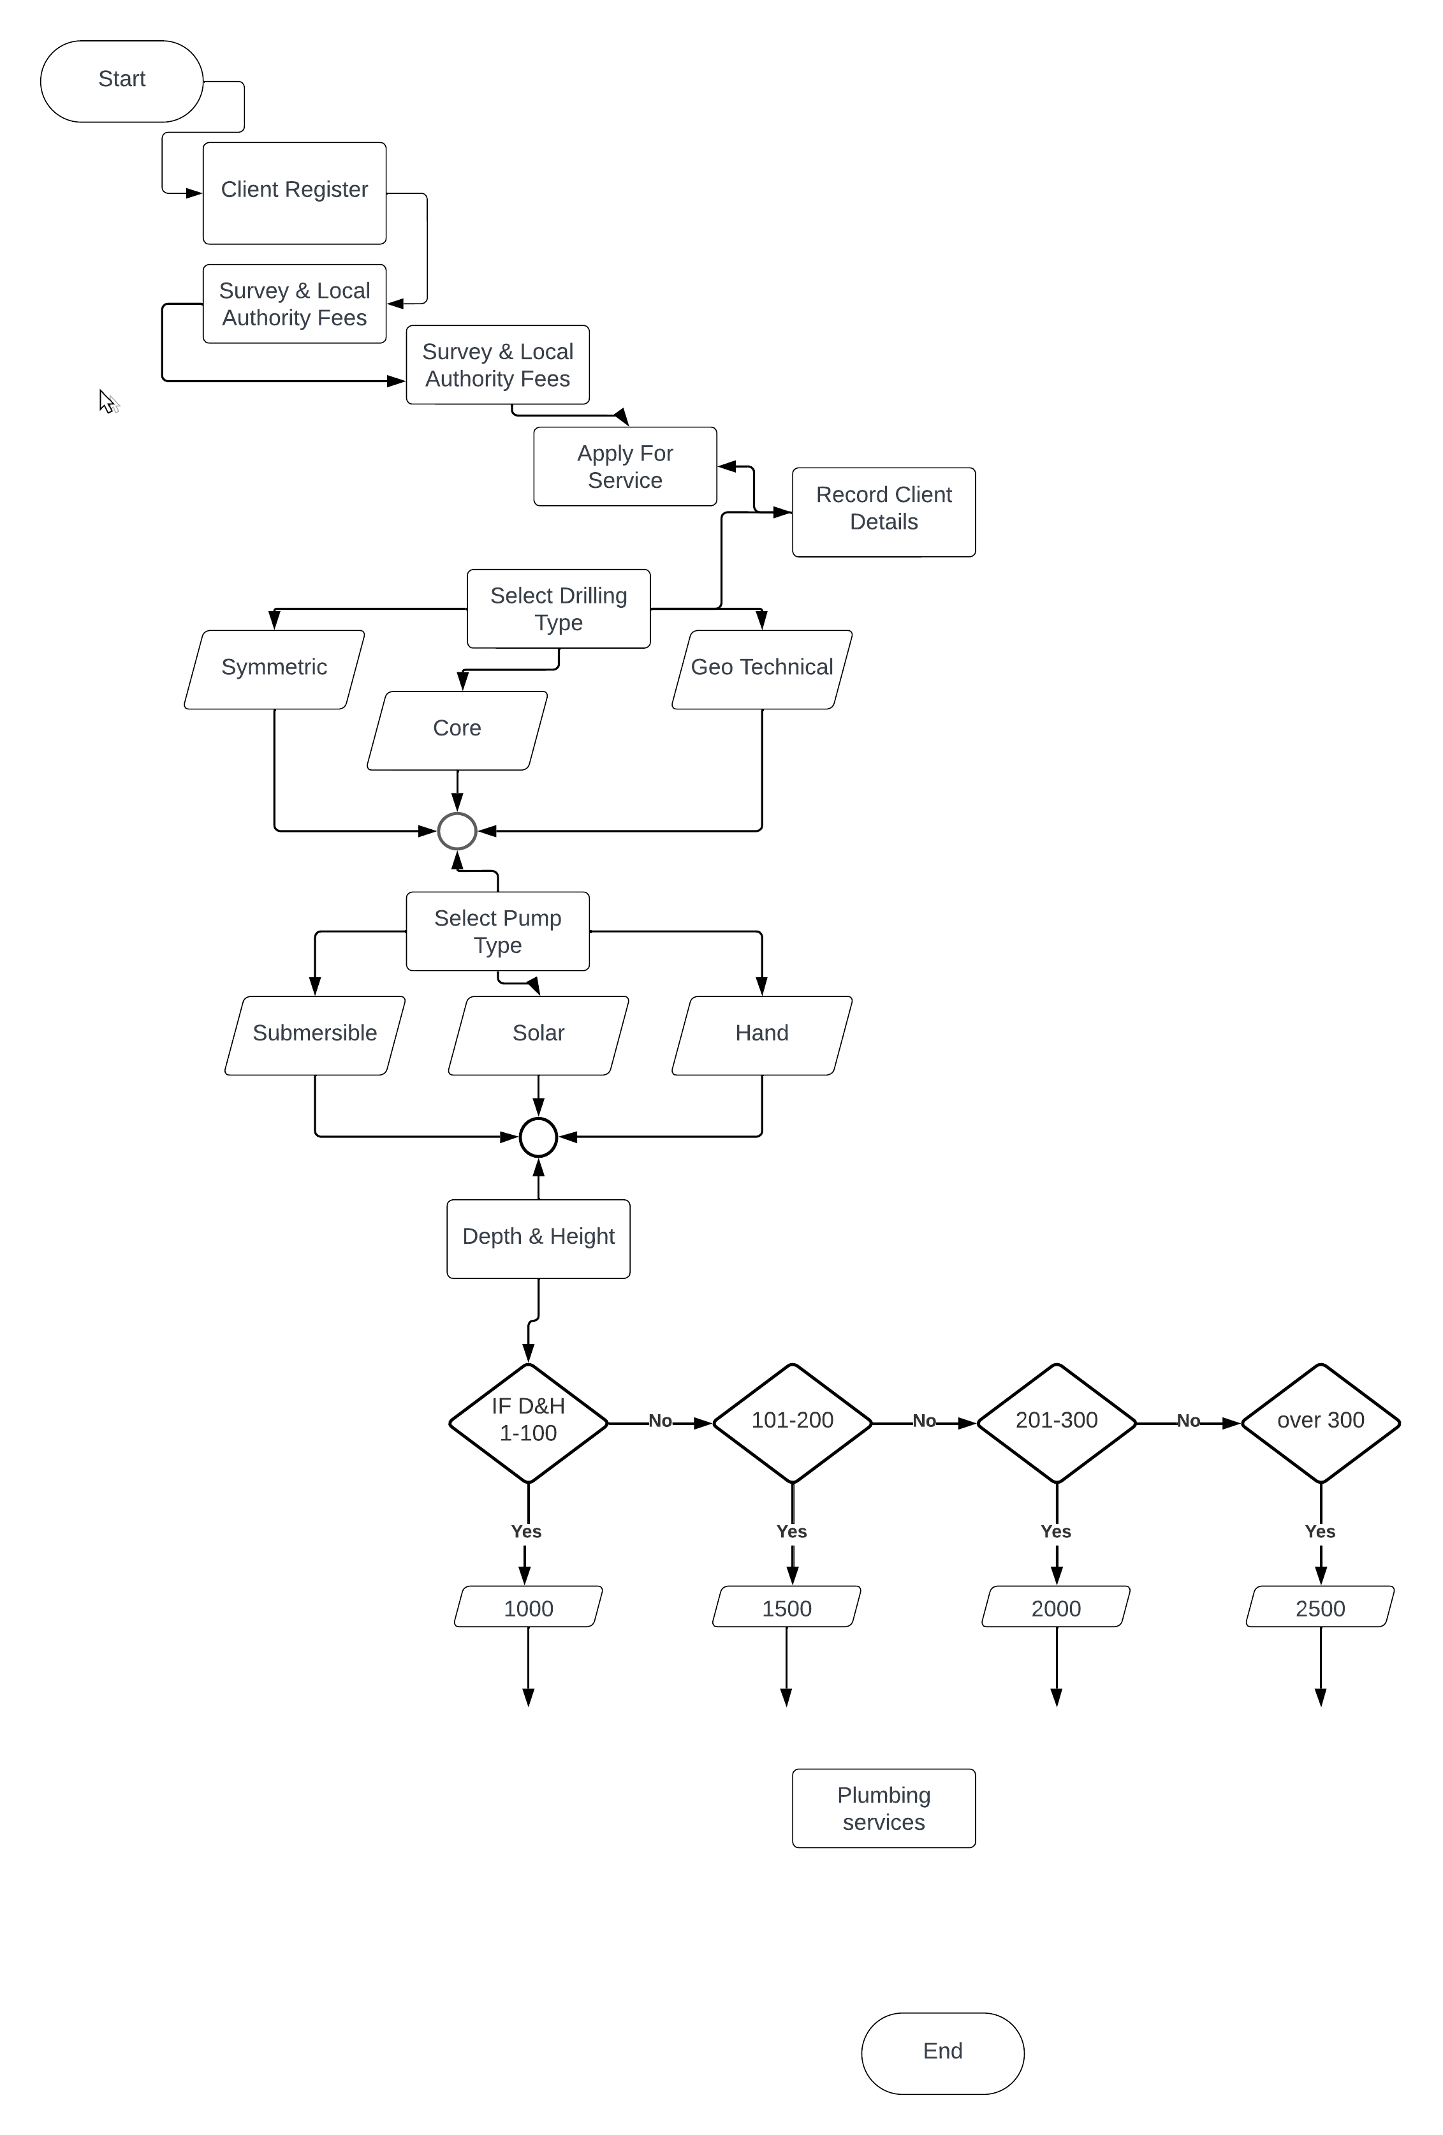](https://lucid.app/lucidchart/f68141cf-3ef8-4dcf-89aa-984d7fd30626/edit?crop=content&page=0&signature=6de98096331d42fed2633b353642ce1c675f0981886a79ac572773021b189f23)

IS PAID?

PAY MEMBERSHIP FEE

MEMBER DETAILS

SENIORS

MIDDLE GROUP

RECORD ITEM SALE IN STOCK IN STORE

PURCHASE AN ITEM

STORE CLERK MAINTAINS RECORDS

**Figure 2**

## 3.2 REQUIREMENT SPECIFICATION

**TABLE DESIGN**

**CLIENTS**

|  |  |
| --- | --- |
| FIELD NAME | DATA TYPE |
| ClientID | Short Text |
| DrillID | Short Text |
| Address | Short Text |
| Telephone Number | Number |
| ClientName | Short Text |

**Table 3**

**BOREHOLE DRILLIING SERVICES TABLE**

|  |  |
| --- | --- |
| FIELD NAME | DATA TYPE |
| ID | Autonumber |
| DrillID | Short Text |
| Type of Drilling | Short Text |
| Down Payment Fee | Currency |

**DRILLING ORDERS TABLE**

|  |  |
| --- | --- |
| FIELD NAME | DATA TYPE |
| ID | AutoNumber |
| ClientID | Short Text |
| ClientName | Short Text |
| Address | Short Text |
| Telephone number | Short Text |

**DRILL TRANSACTIONS**

|  |  |
| --- | --- |
| FIELD NAME | DATA TYPE |
| Trans# | AutoNumber |
| DrillID | Short Text |
| ClientID | Short Text |
| TankCapacity(ltr) | Number |

**PLUMPING TABLE**

|  |  |
| --- | --- |
| FIELD NAME | DATA TYPE |
| PlumpingID | AutoNumber |
| ClientID | Short Text |
| TypeOfPipes | Short Text |
| Diameter(inches) | Number |
| Lenght | Number |
| NumberOfOutlets | Number |
| Totals | Currency |

**PUMP INSTALLATION**

|  |  |
| --- | --- |
| FIELD NAME | DATA TYPE |
| InstallationID | Short Text |
| PumpID | Short Text |
| Type of Pump | Short Text |
| Cost | Currency |

**PUMP TRANSACTIONS**

|  |  |
| --- | --- |
| FIELD NAME | DATA TYPE |
| Trans# | AutoNumber |
| ClientID | Short Text |
| PumpID | Short Text |
| Depth | Number |
| Height | Number |

**SURVEY AND LOCAL AUTHORITY FEES**

|  |  |
| --- | --- |
| FIELD NAME | DATA TYPE |
| ID | AutoNumber |
| ClientID | Short Text |
| ClientCategory | Short Text |
| ServeyFees | Currency |
| LocalAuthorityFees | Currency |

**THIS IS AN EXAMPLE (MAKE SURE YOU CREATE THE SKELETON LIKE THIS IN EVERY FORM)**

**INPUT SPECIFICATION**

**CLASS**

CLASS ID

TEACHER ID

CLASS

STREAM

NUMBER OF STUDENTS

## 3.3 INPUT AND OUTPUT DESIGN

### 3.3.1Input design

**ADD A PUMP MEMBERS**

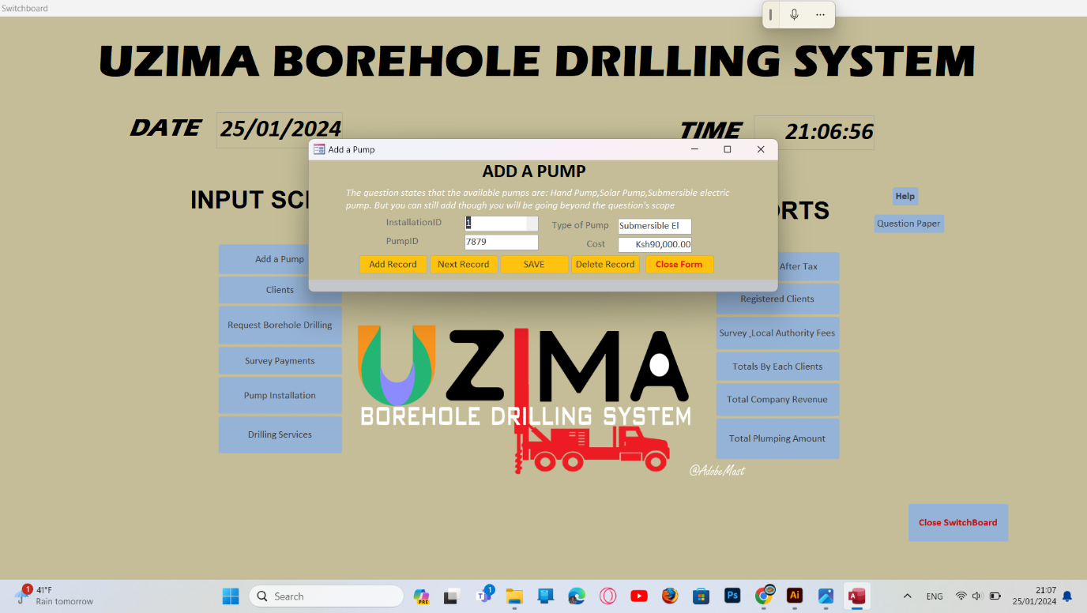

**Figure 3**

**REGISTER AS A CLIENT FORM**

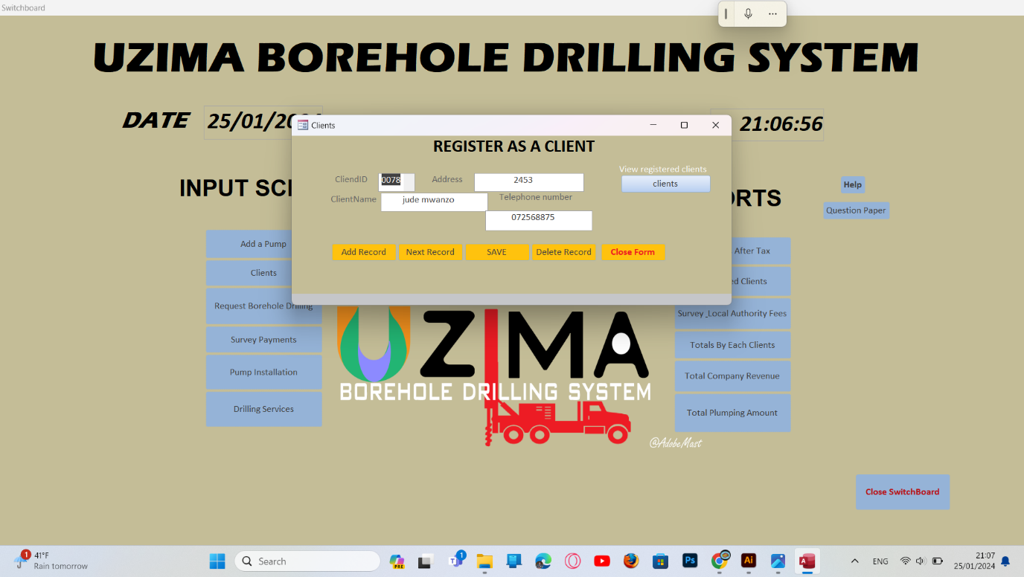

**Figure 4**

**BOREHOLE DRILLING FORM**

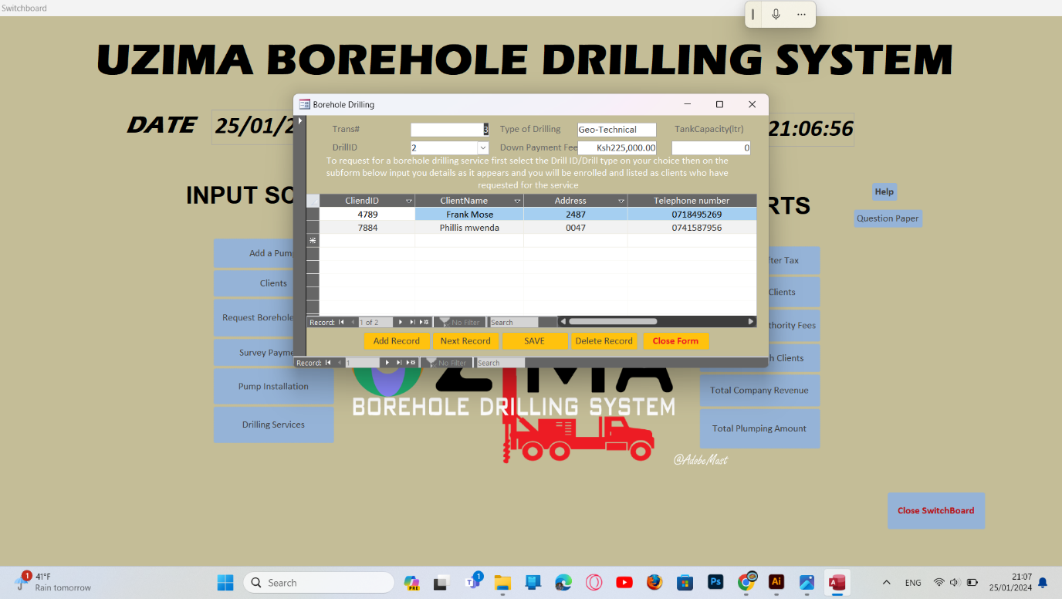

**Figure 5**

**SURVEY AND LOCAL AUTHORITY FEES FORM**

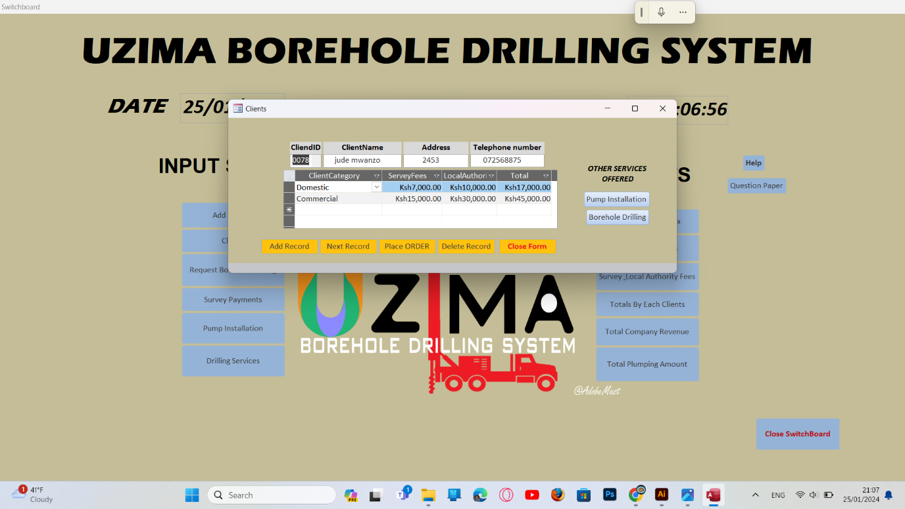

**Figure 6**

**PUMP INSTALLATION FORM**

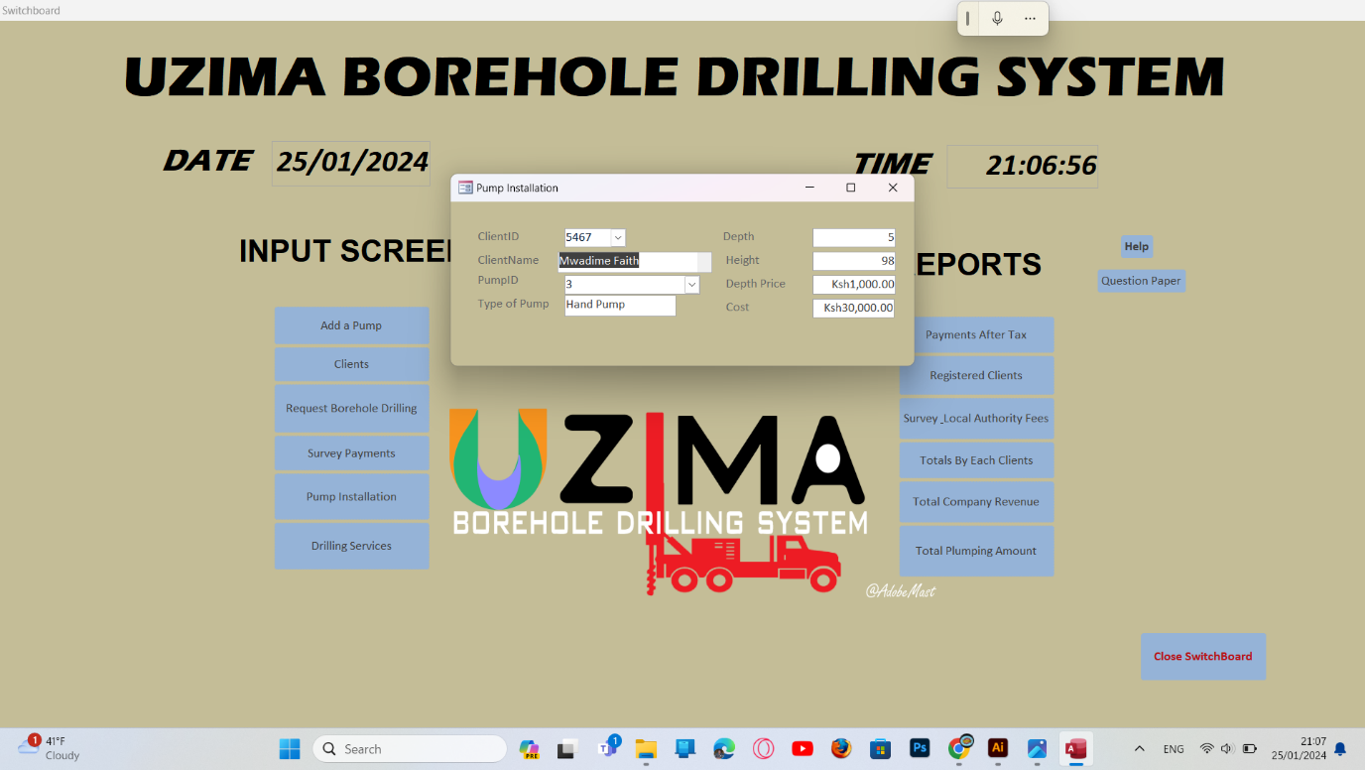

**Figure 7**

**ADD A DRILLING OFFER**

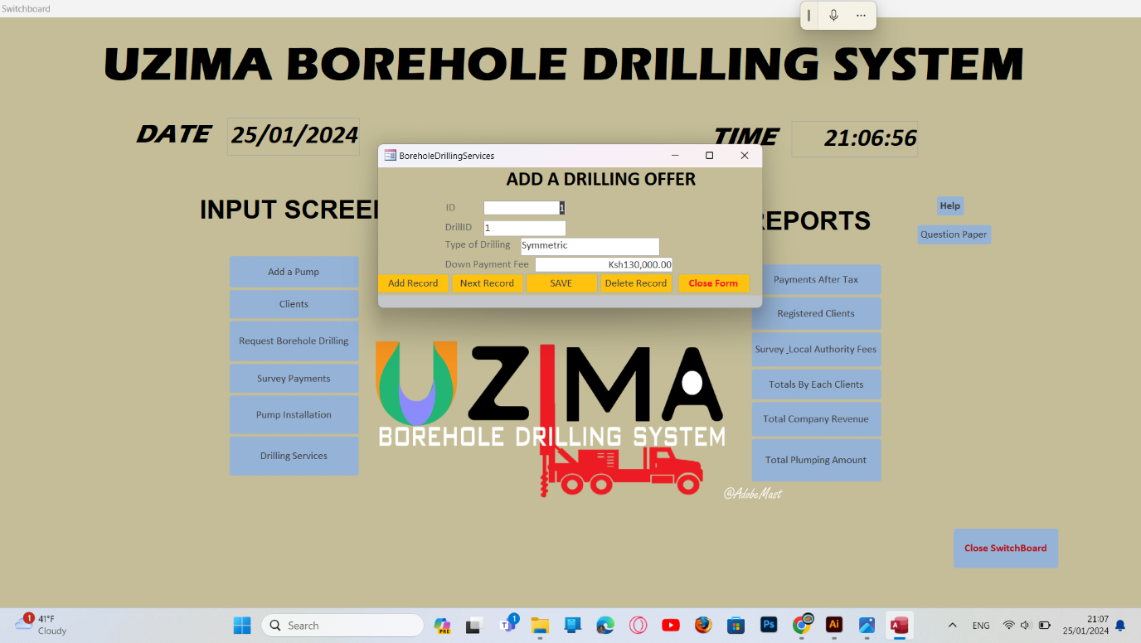

### 3.3.2File and data storage time

There are two types of data storage, namely;

* + Flat files
  + Database files

**Database**

In the construction of Uzima Borehole Drilling System, the system analyst decided to use this approach because it will have the following objectives:

* Easy access by the users
* Sharing of data amongst the users of the system
* There is back up of data and can be done easily
* Maintaining of accounts and control of data access
* Availability of data for current and future use

### 3.3.3 Entity-relationship diagram

Entities that may be used in constructing Uzima Borehole Drilling System are Clients, Registration, Drilling Service, Pump installation, Survey and local authority fees and Drilling service. The first step is to construct relationship diagram as below.

Orders Drilling service

Drilling

Survey and Local/A fees

Registration

Tanks/Plumbing

**Figure 16**

### 3.3.4 Interpretation

The system has several staff members who are either in the or in the money records but through the identification of purchases one can one can be able to be paid through invoice or cash depending on his sales.

**Summary of hardware requirements**

|  |  |  |
| --- | --- | --- |
|  | Hardware facility | Example |
| 1 | Computer | IBM desktop computer |
| 2 | Storage media | Optical disks  Magnetic disks |
| 3 | POS terminal equipment | Magnetic card |
| 4 | Printers | Laser printer |
| 5 | Scanners | Flatbed Scanner |

**Table 15**

**Summary of software requirements**

|  |  |  |
| --- | --- | --- |
|  | Software | Example |
| 1 | GUI based OS | MS-Windows 9x, XP |
| 2 | Application program | MS-Office Suite |
| 3 | Antivirus software | Kaspersky |

**Table 16**

# CHAPTER FOUR

# SYSTEM CONTRUCTION

Because relational databases store data in a series of two-dimensional tables, the first step in designing the information base is to design tables that are related to each other via primary key and foreign keys. Throughout this section the following short hands will be encountered.

PK-Primary Key

FK-Foreign Key

Tables ClientID (PK)

Company ClientID (FK)

**Figure 17**

## 4.1 SETTING UP INTEGRITY CONSTRAINTS

After setting database based on the entity relationship diagram, some integrity constraints need to be set in the database to enhance accuracy. Examples of constrains are lookup fields and data integrity constraints.

**Creating a lookup**

A lookup field displays a list of acceptable values that may be entered into a field. This avoids the problem of wrong data entry in a field.

To create a lookup field:

1. Display the table in design view.
2. Select lookup wizard in the data type column of the desired fields.
3. Complete the prompts in the lookup wizard.

Example of lookup wizard

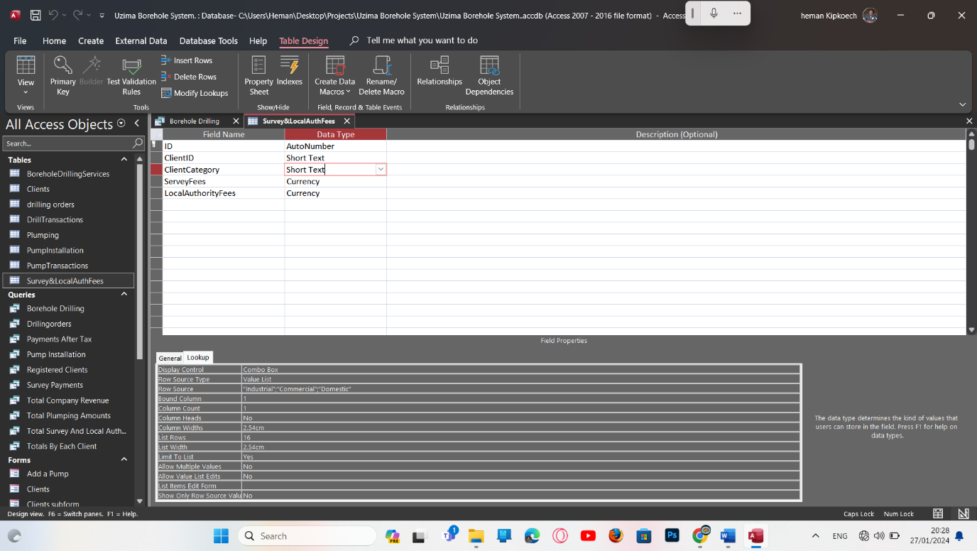

**Figure 17**

You then choose the option you require from the choices available

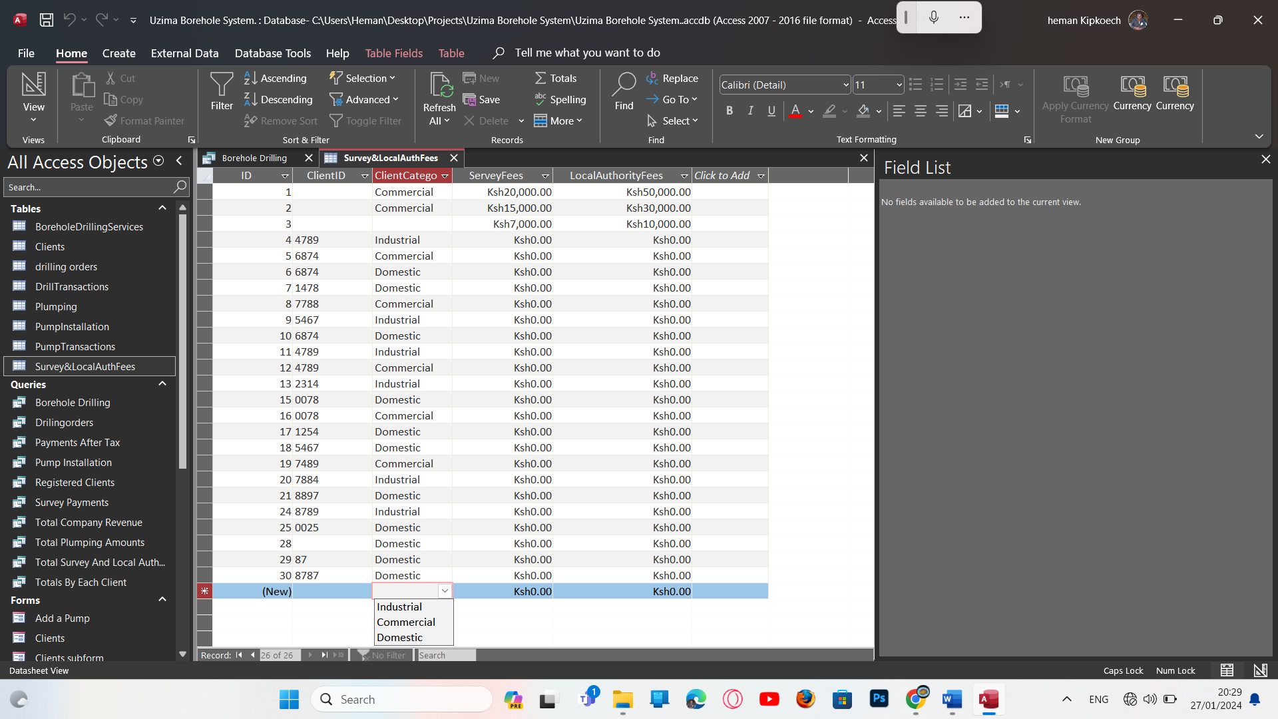

**Figure 18**

## 4.2DATA ENTRY CONSTRAINTS

These are rules that govern entering, changing and deletion of data and records in a database. Types of integrity constraints include:

* Entity integrity constraint
* Referential integrity
* Domain integrity

**Entity integrity**

It governs composition of primary key. Primary key do not contain a null value. The example of use of the primary is below and it states that the ClientID is the primary hence no duplication.

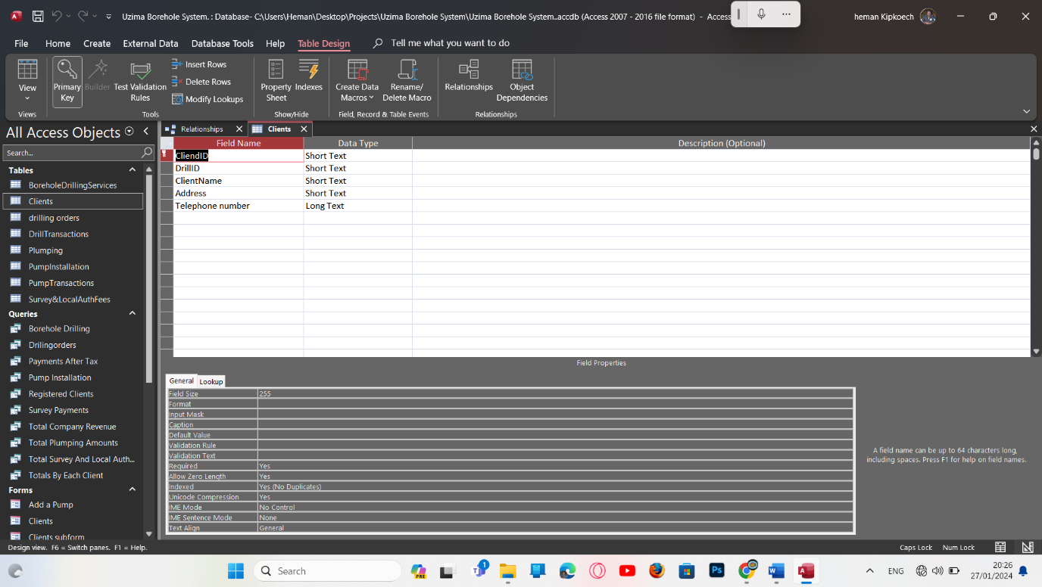

**ClientID does not allow duplicates.**

**Figure 19**

**Referential integrity**

It governs the nature of records in one too many relationships between entity tables in a table.

It can be implemented in the following ways:

1. Restricted database-the system deletes or updates a stock record if there are no issuances of books records.
2. Cascaded it deletes or updates all penalties records when the replacement of books record is deleted.

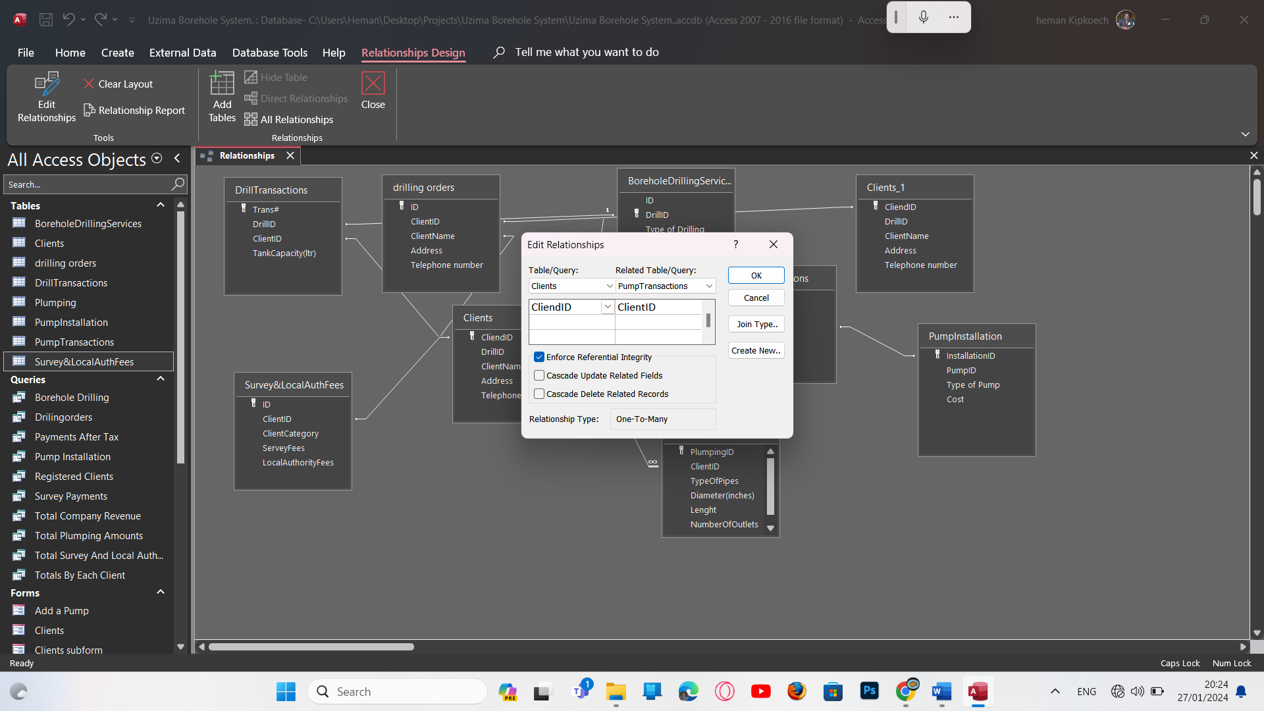

**Figure 20**

**Domain integrity**

It ensures no field takes a on a value outside the range of valid values.



### Figure214.2.1Constructing data entry and user interface forms

**Primary Form**

They are used to enter data into tables.

CLIENTS TABLE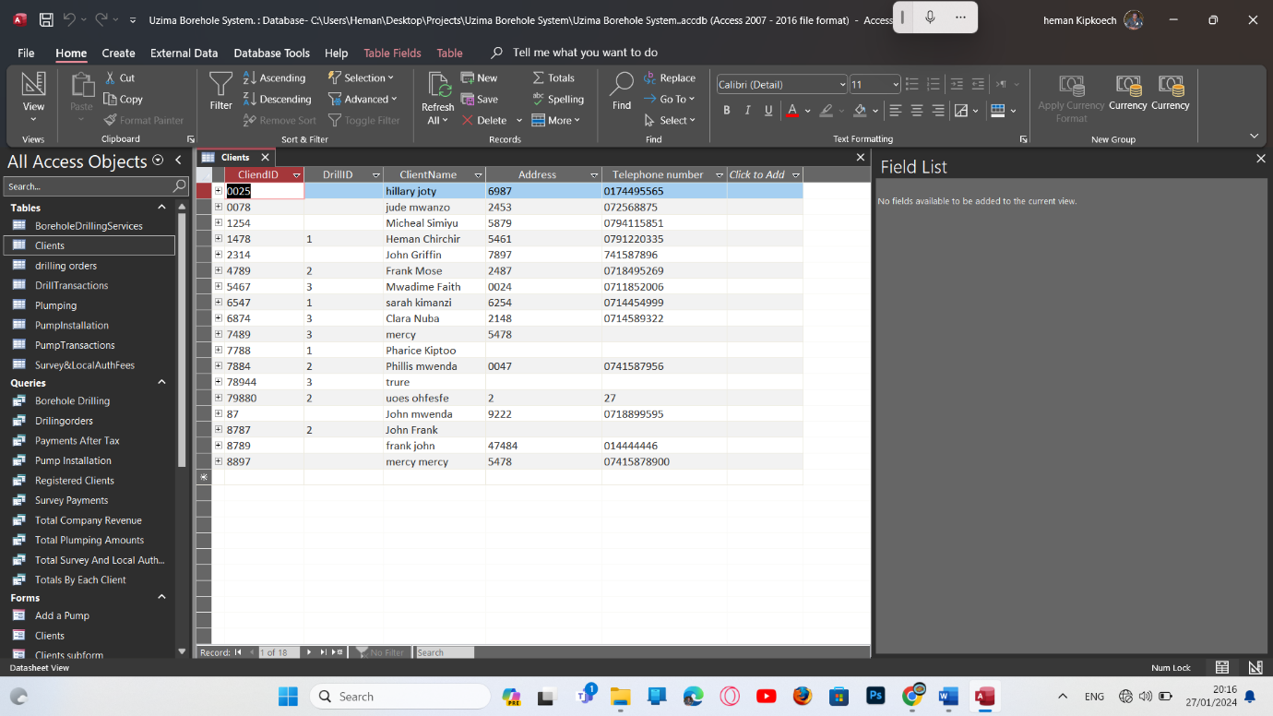

**Figure 22**

**BOREHOLE DRILLING SERVICE TAB LE**

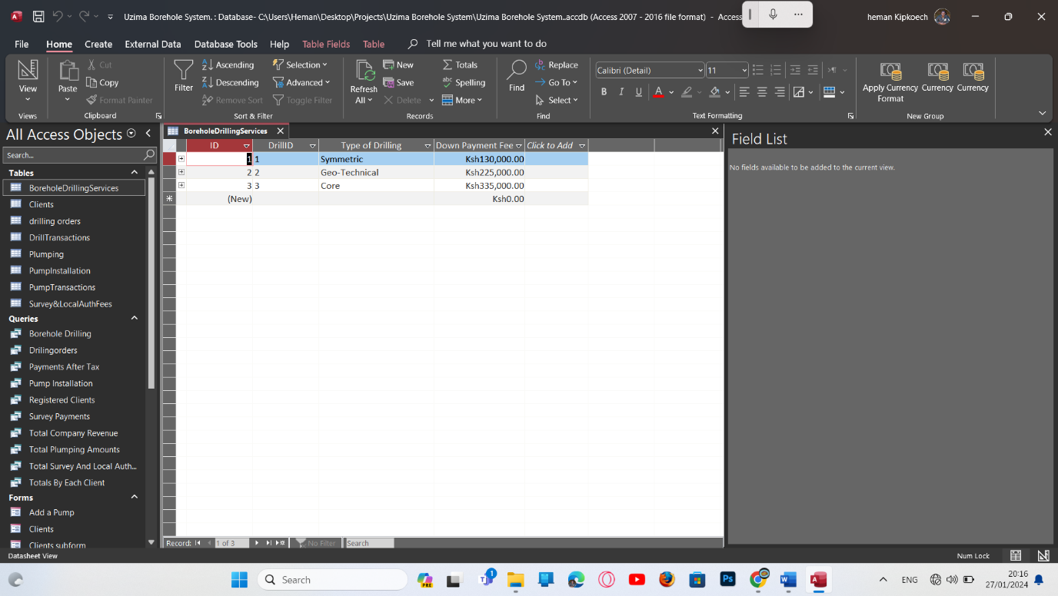

**Figure 23**

**DRILLING ORDERS TABLE**

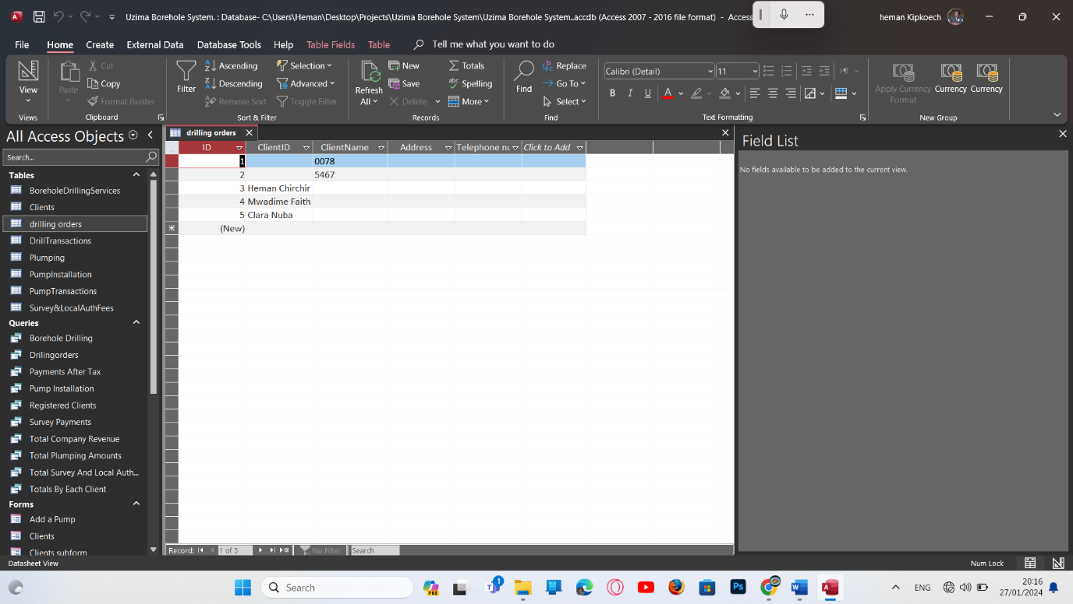

**DRILL TRANSACTIONS TABLE**

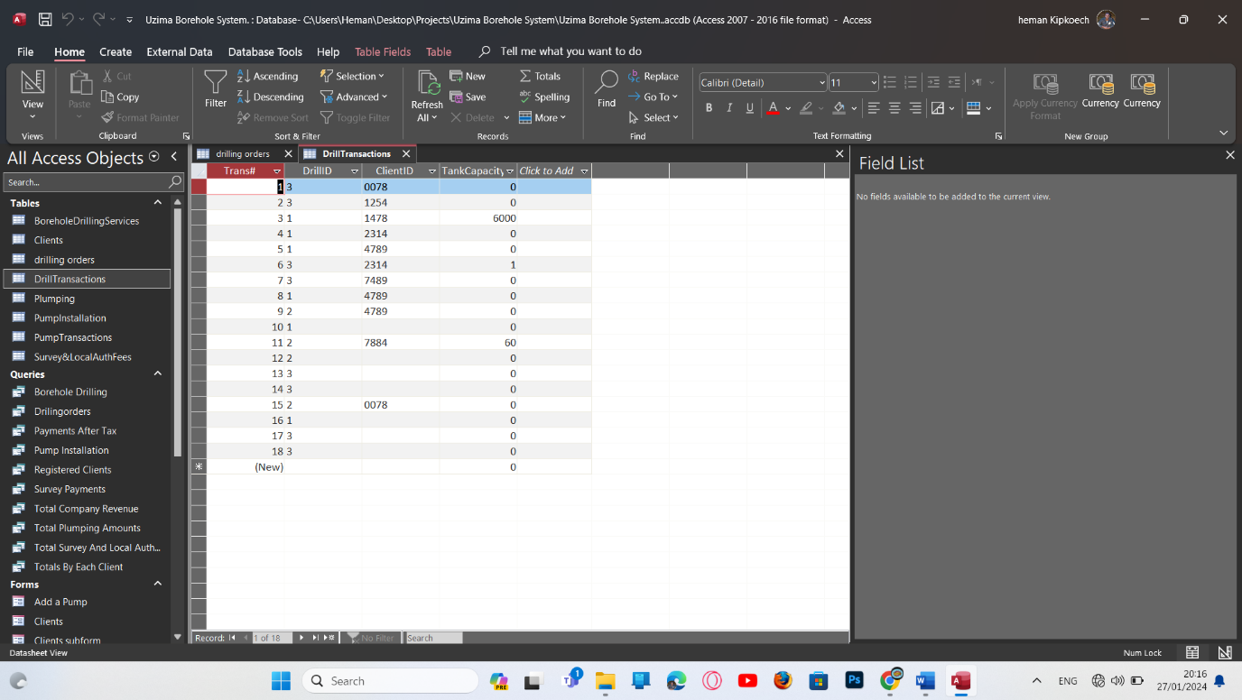

**PLUMPING TABLE**

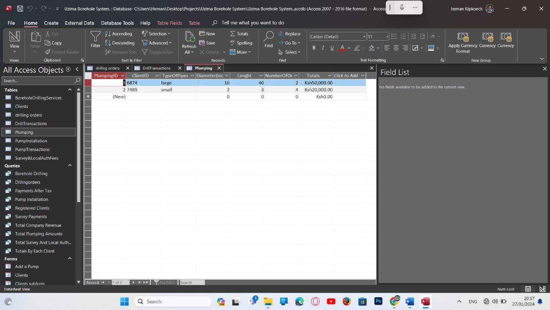

**PUMP INSTALLATION**

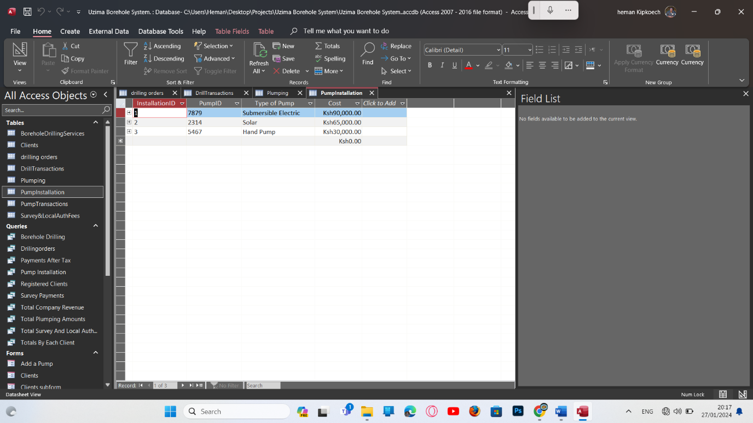

**PUMP TRANSACTIONS TABLE**

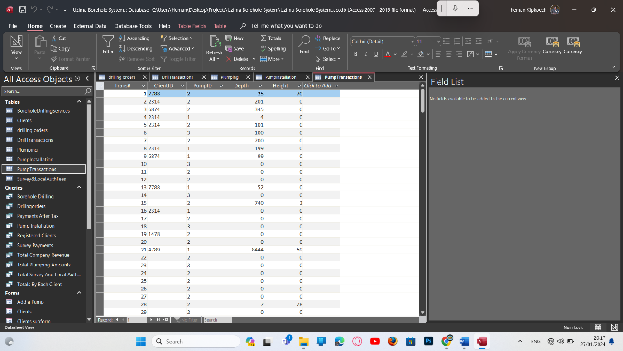

**SURVEY AND LOCAL AUTHORITY FEES TABLE**

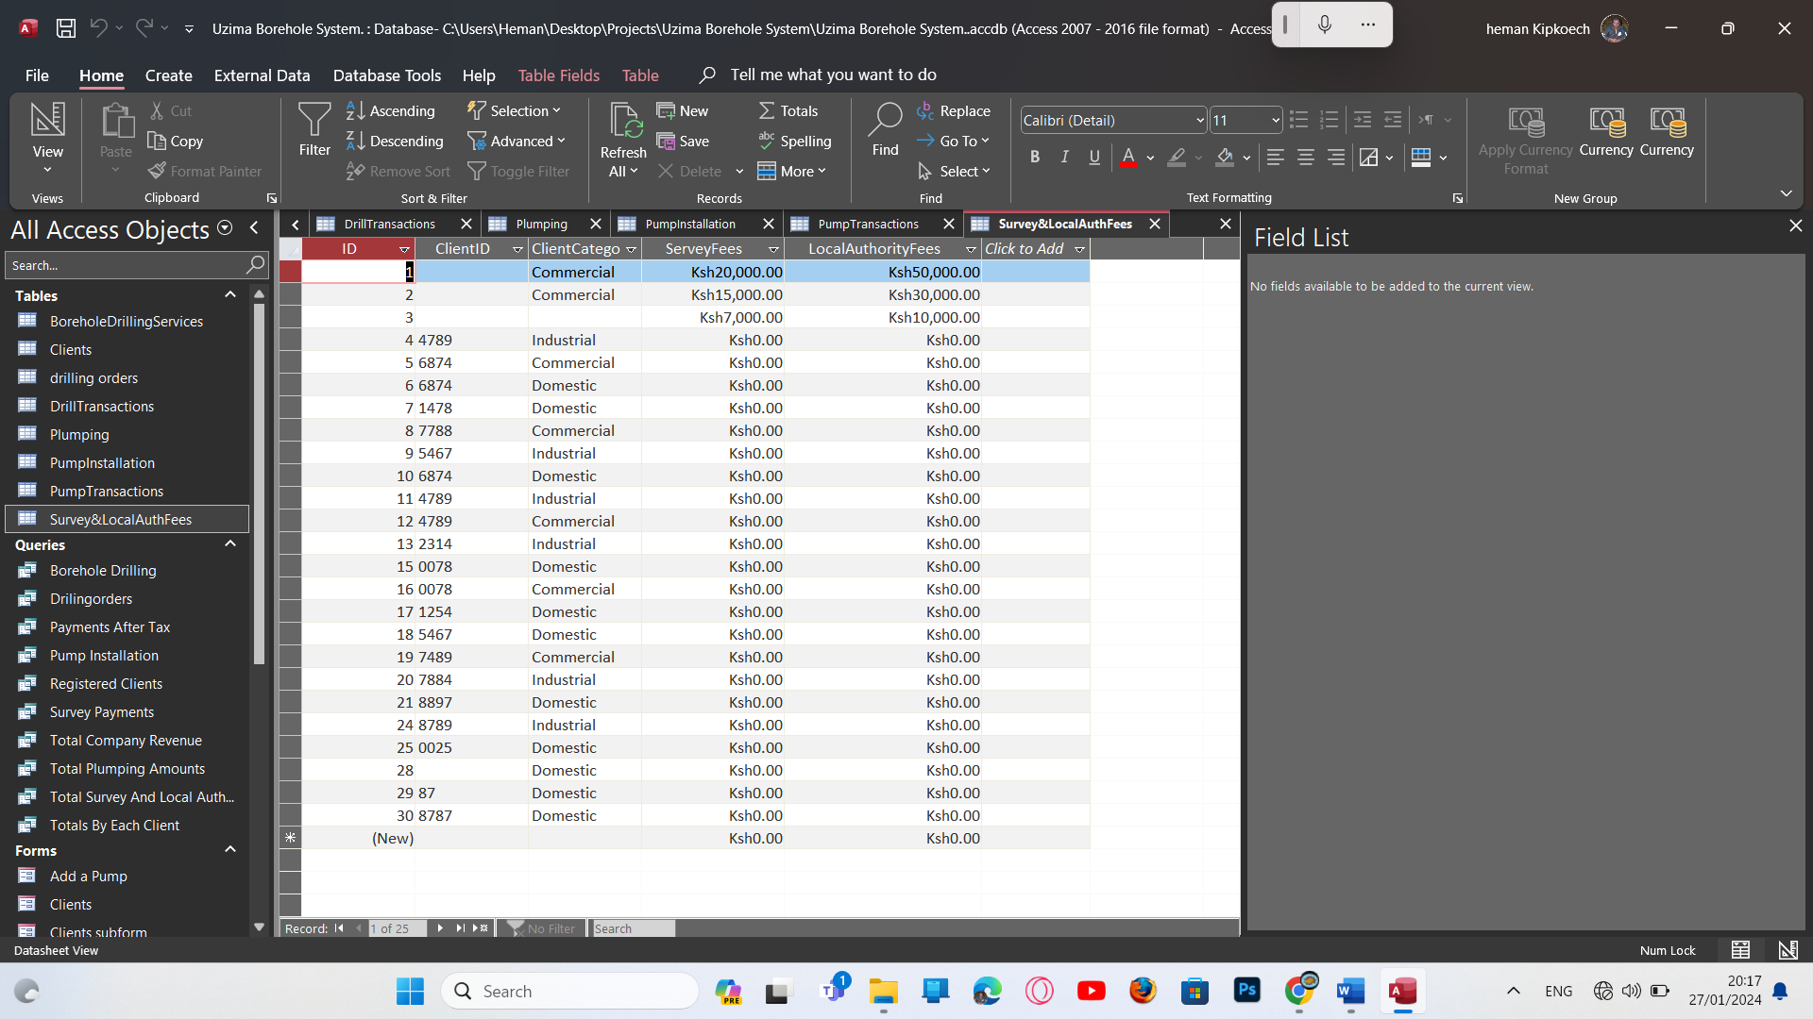

**CREATING REPORTS**

**PAYMENTS AFTER TAX**

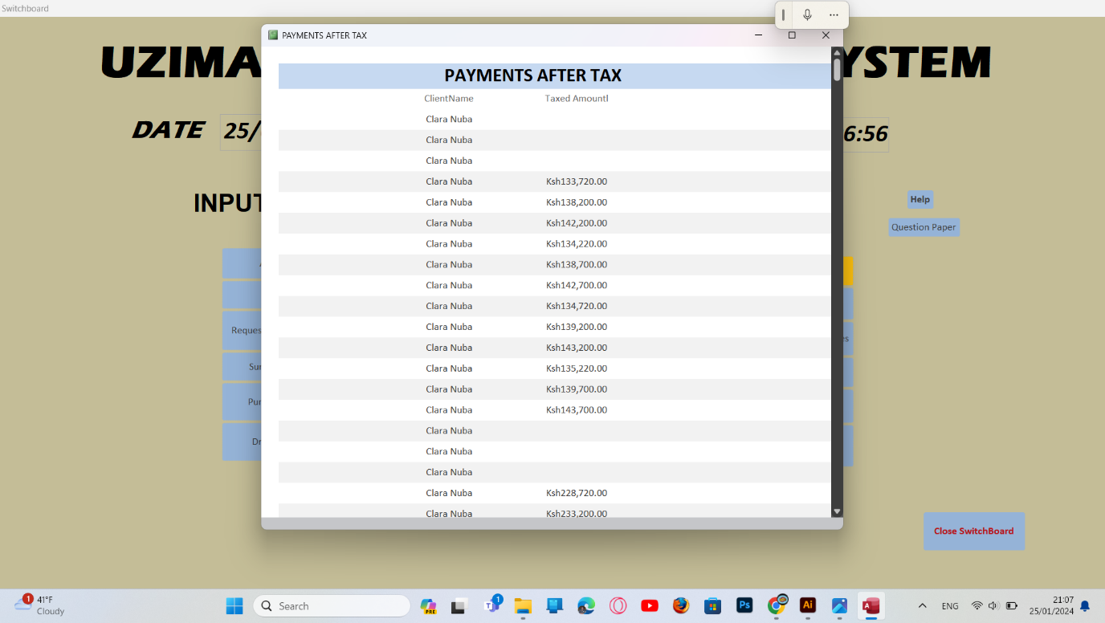

**Figure 24**

**REGISTERED CLIENTS**

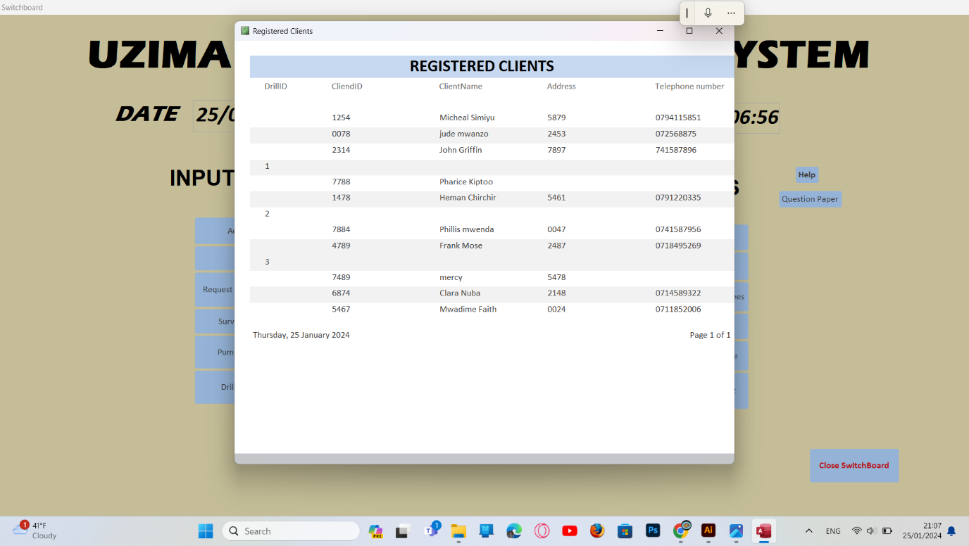

**Figure 25**

**SURVEY AND LOCAL AUTHORITY FEES**

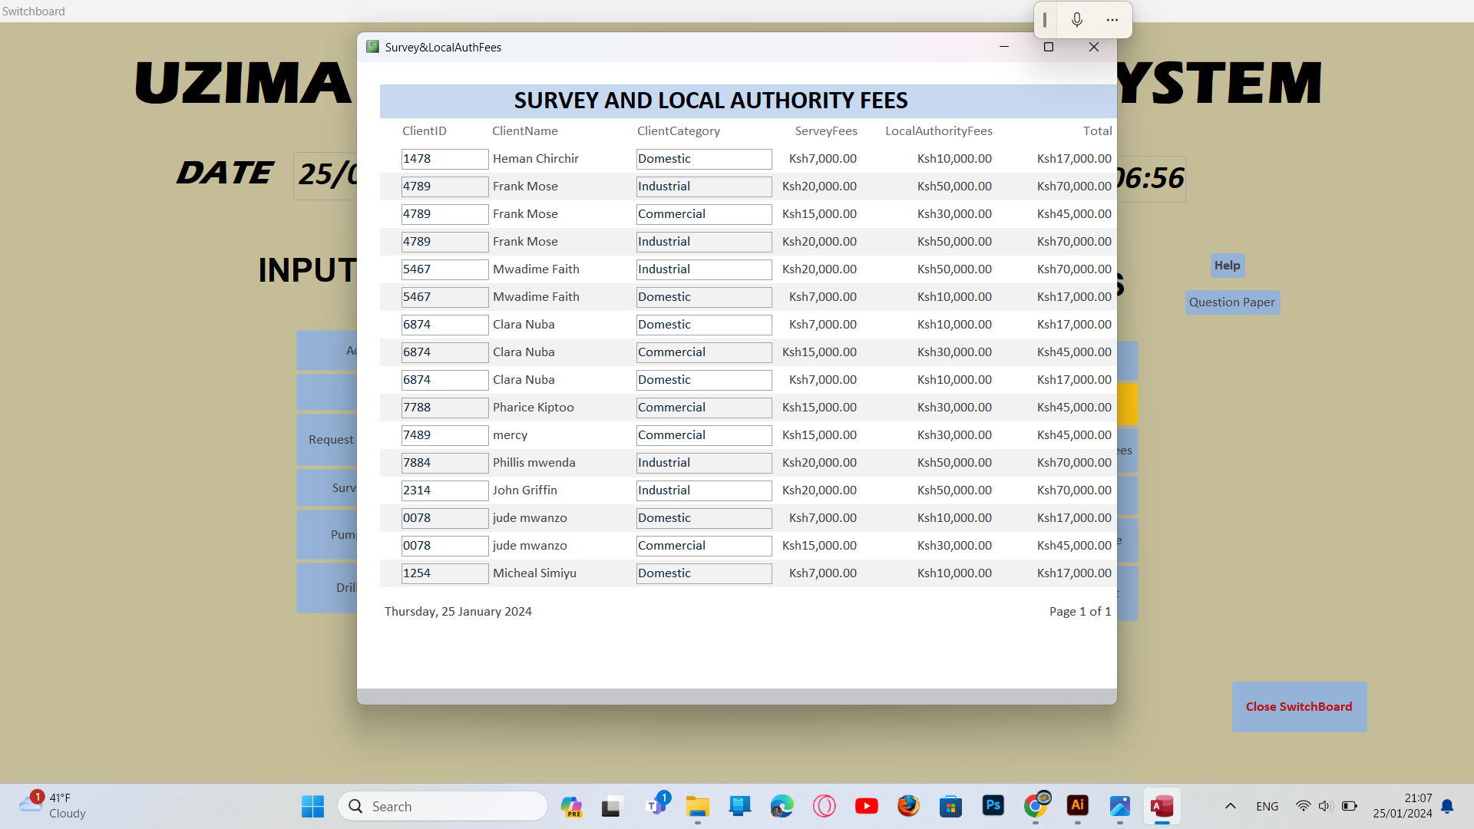

**Figure 26**

**TOTALS BY EACH CLIENT**

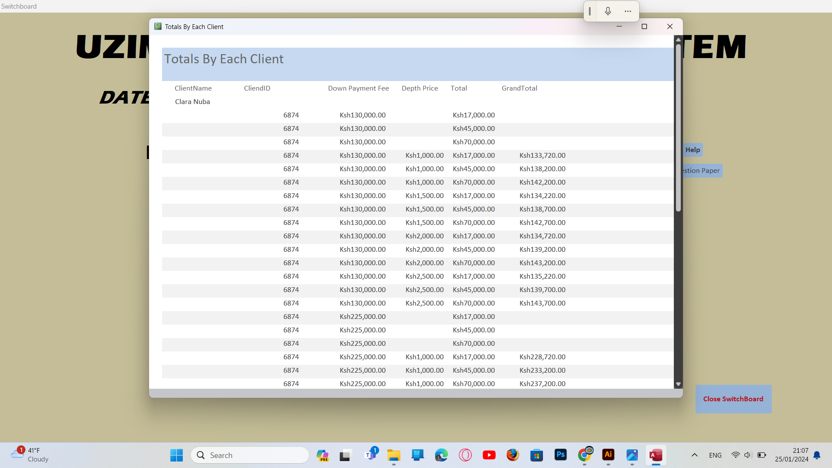

**Figure 27**

**TOTAL COMPANY REVENUE**

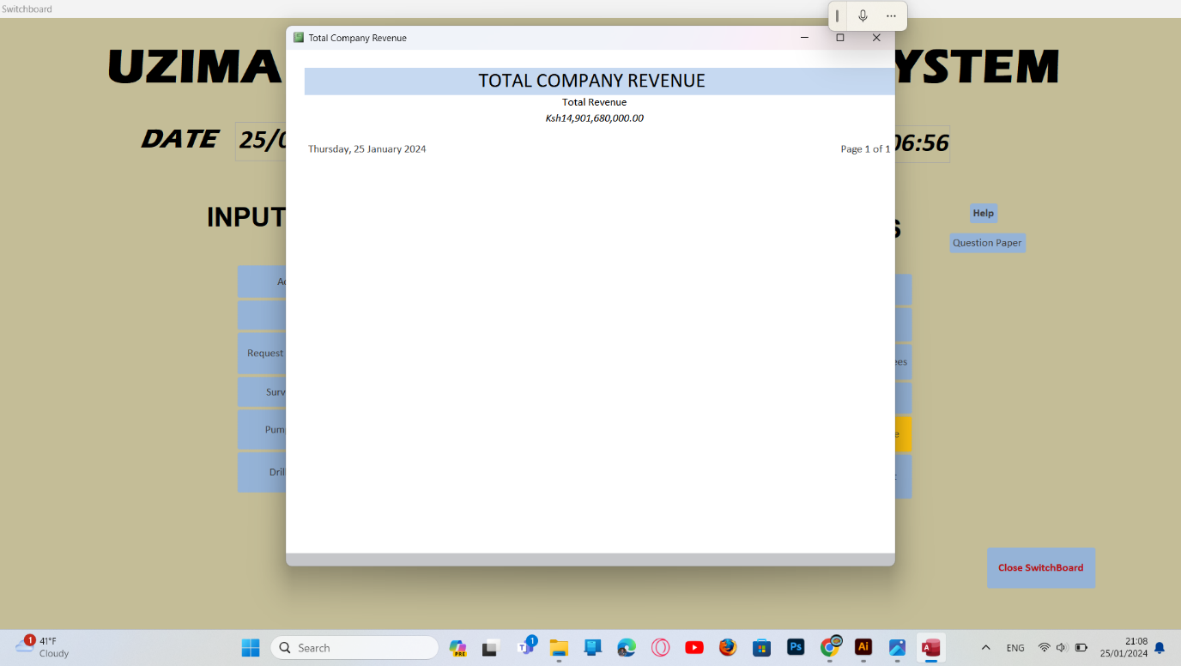

**Figure 28**

**TOTAL PLUMPING AMOUNT**

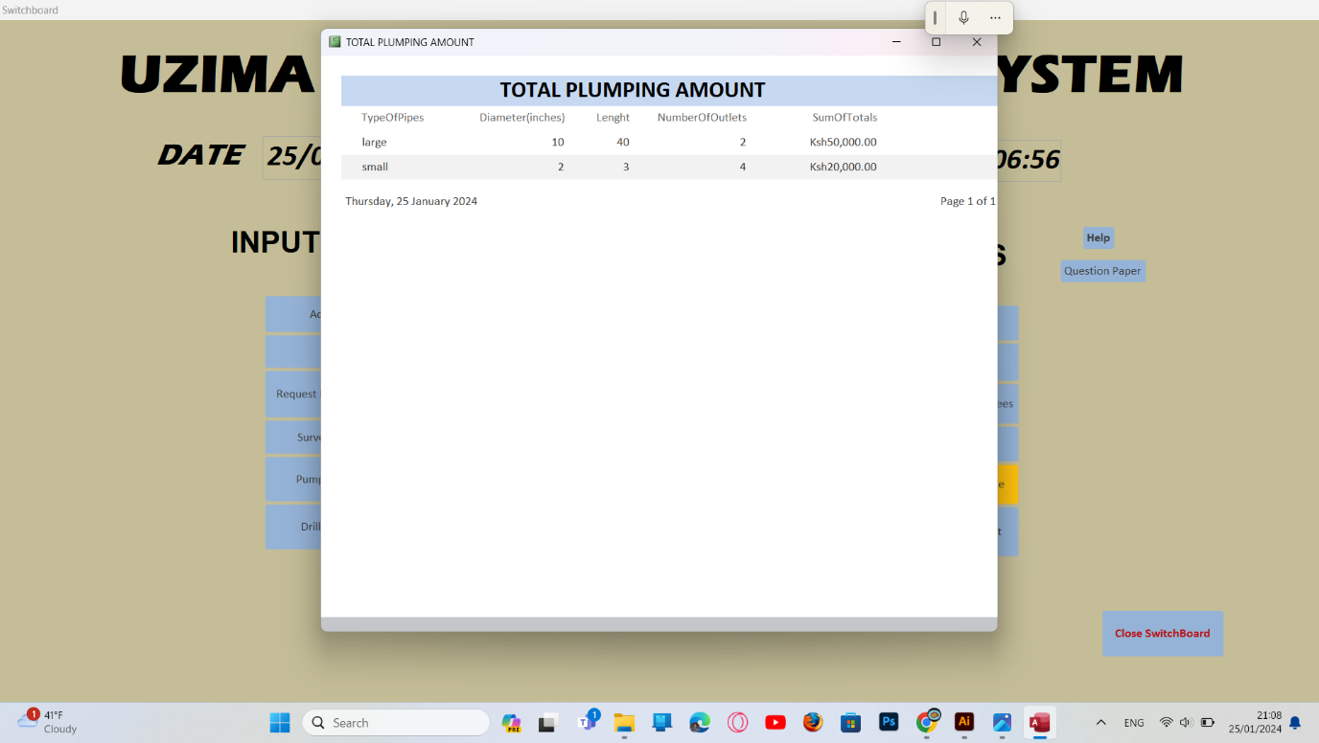

**Figure 29**

**Figure 30**

**Figure 31**

**Figure 32**

**Creating relationships**

This helps to relate one to more tables

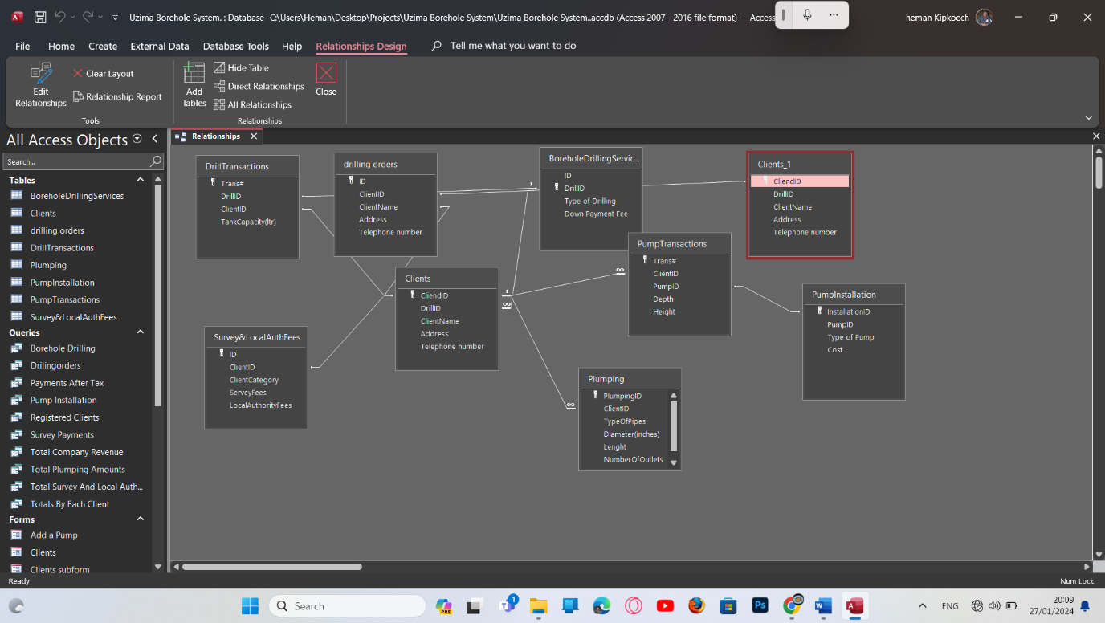

## 4.3 STARTUP OPTIONS AND LOADER

**Start Up Options**

The last step in developing a customized application is to specify the start-up options.

Below is the start-up setting for Uzima Borehole Drilling System

**Figure 36**

**Figure 37**

***SWITCHBOARD***

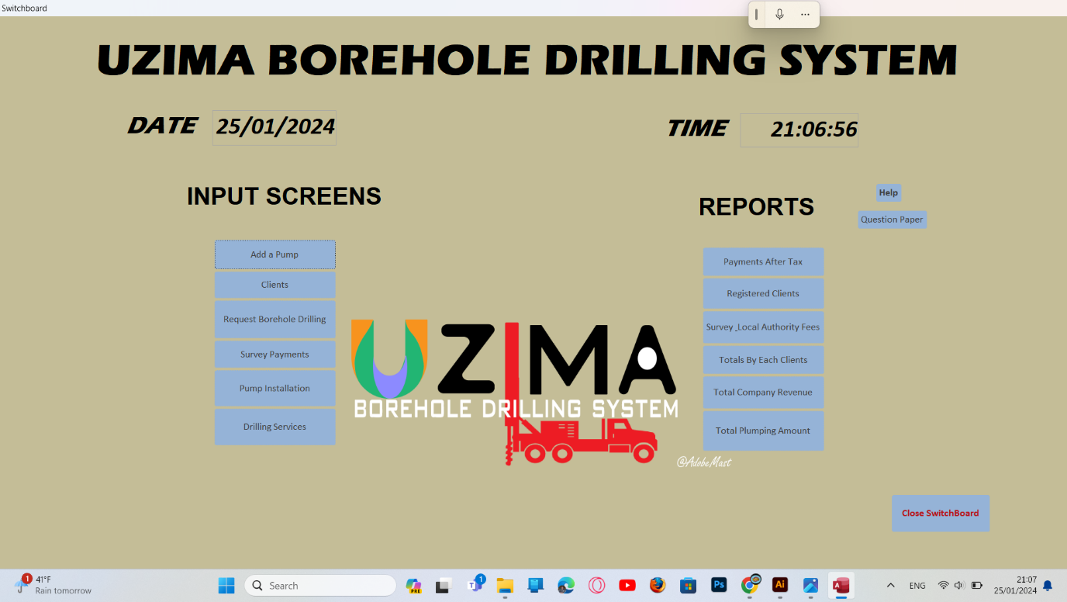

### 4.3.2 Testing and implementing the system

**Testing**

Individual system modules were tested using test data and dry running and were found to work accurately and properly.

**Implementation**

The tasks carried out during system implementation stage are:

* Farmers training- this is done without interfering with the group operations
* System this involves installation, resource and group allocation
* security control and contingency planning incase the system breaks down
* changing over from old system to the new system

### 4.3.3 Recommendation and conclusion

The new system received a very high rate recommendation from all the users after the first month of its operation.

# CHAPTER FIVE

# USER MANUAL

## 5.1 INTRODUCTION

Uzima Borehole Drilling System is a system developed to carry out the processes of entering its records and store their details efficiently and accurately for present and future use.

**Installing Uzima Borehole Drilling System**

* Open Uzima Borehole Drilling System on a CD or any other storage device.
* Right click the project and click OK
* Paste it on your System

## 5.2 LOADING THE UZIMA BOREHOLE DRILLING SYSTEM

To open the program:

* Click the START button and point to programs menu.
* Click Uzima Borehole Drilling System. `
* The Uzima Borehole Drilling System opens as a database.
* Click on OK and it will open the switchboard to manipulate your data.

## 5.3 MODIFYING A FORM

**Adding a New record**

* Open the Uzima Borehole Drilling System
* Open the form where the new record is to be added
* Click on the command add button present on the form
* Add the new record then close the program

**How to delete a record**

* Open the Uzima Borehole Drilling System
* Open the form where the new data is to be deleted and then the record to be deleted.
* Click on the command delete present on the form.
* A dialogue box will appear asking whether you want to delete the record.
* Click YES and close the program after deleting.

## RECOMMENDATION

I would recommend the ministry of education to continue issuing the projects to students and at early time to ensure its completeness on time. Through the working out of the project, the students get great opportunity in pursuing their careers and continue with future life as they are able to solve the daily related problems encountered to such programs.

## CHALLENGES

In coming up with this project I have encountered some difficulties which include

* Inadequate time during information gathering
* Breakdown of program constructed
* Loss of information due to virus
* Inadequate reference during information gathering
* Breakdown of computers is a major cause

## 

## **CONCLUSION**

This project has helped me to become a system analyst and I can now create a new project without much difficulties.

# APPENDIX

## FLOWCHART SYMBOLS AND THEIR MEANING

1. Arrow: used to indicate the direction of the flow of program logic

1. Rhombus: Used to specify a condition

3. Parallelogram: used to denote an input or output operator

4. Rectangle: Used to indicate that a process is taking place

5. Used as a disk master file

## BIBLIOGRAPHY/REFERENCES

The following are reference Materials I used to come up with Uzima Borehole Drilling System

* *S.Mburu G. Chemwa* Longhorn computer studies secondary book 4, 6th edition Longhorn publisher2002
* *S.Mburu G. Chemwa* Longhorn computer studies secondary book 3, 6th edition Longhorn publisher 2003
* *Jonah Lang’ at, Douglas Musonye, Antony Wanjohi* Foundation Computer studies book 3, 4th edition Jomo Kenyatta Foundation Publisher ltd 2005.
* *Douglas Musonye, Antony Wanjohi* Foundation Computer studies book 4,4th edition Jomo Kenyatta Foundation Publisher 2005.